BORDER BIG & LITTLE NEWS

Our Vision:
Big Brothers Big Sisters of Lloydminster is dedicated to the growth of mentoring to ensure that every child or youth who needs a positive ongoing relationship with a caring mentor will have one.
Our Mission:
Our organization is committed to being leaders in our community for providing the highest quality; volunteer based mentoring programs to our community’s young people.

Remembrance Day
Sunday Nov.11, 2018

No Program Nov.12-16, 2018  Find the monthly kids quote  In our newsletter! | Check us out on Facebook!  Big Brothers Big Sisters of Lloydminster | #3 – 4301 49th Avenue  Lloydminster, SK. S9V 0S5  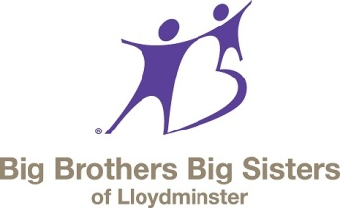

Recycling: Designated Driving: Controlling:
Every Wednesday @ 9:00am Nov.17 @ Rolling Greens Nov.16, 17 @ Christmas Craft Show
Nov. 24 @ Stockade Nov. 24 @ Christmas House Light Launch

iF YOU ARE AVAILABLE TO HELP OUT PLEASE CALL OUR OFFICE AT 306-825-5757.

****REMINDER; UNLESS WE CONTACT YOU THAT AN EVENT YOU ARE SCHEDULED FOR IS CANCELLED, IT’S STILL A GO!!***

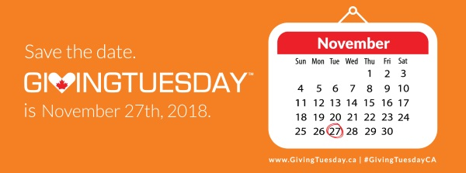

Join the GivingTuesday movement.

After Black Friday and Cyber Monday it’s GIVINGTUESDAY—a day dedicated to giving! On Tuesday, November 27th, join the GivingTuesday movement.
Wondering how to donate? Find us online at CanadaHelps.org to donate via credit card or paypal, mail us a cheque or stop in at our office to make your in person donation of cash or cheque.

“If our hopes of building a better and safer world are to become more than wishful thinking, we will need the engagement of volunteers more than ever.” — Kofi Annan
PARENT SHIFTS REMINDER
Volunteer shifts are from September to August each year.
-If your child is part of the afterschool and/or summer program we ask that you complete 18 shifts per year.
-If your child is on the waiting list or matched but does not attend afterschool or summer program we ask that you complete 9 shifts per year.
Thank you!
EXTRA SHIFT OPPORTUNITY
FUNDRAISING COUPONS
NEW CO-OP Coupons: Two $25.00 Coupon Books = 1 Shift
PANAGO: Four $12.00 Pizza Coupons = 1 Shift

Thank you to the following community members for their generous donations to BBBS Lloydminster:

CO-OP
MIDWEST MOBILE SECURITY
STARBUCKS
CONA RESOURCES
SERVUS
MUBASHARA A.
DOREEN & DALE M.
JOHN T.
BIOCLEAN DISASTER SERVICES
JIM P.
BORDERTOWN HOGS
BAR ENGINEERING

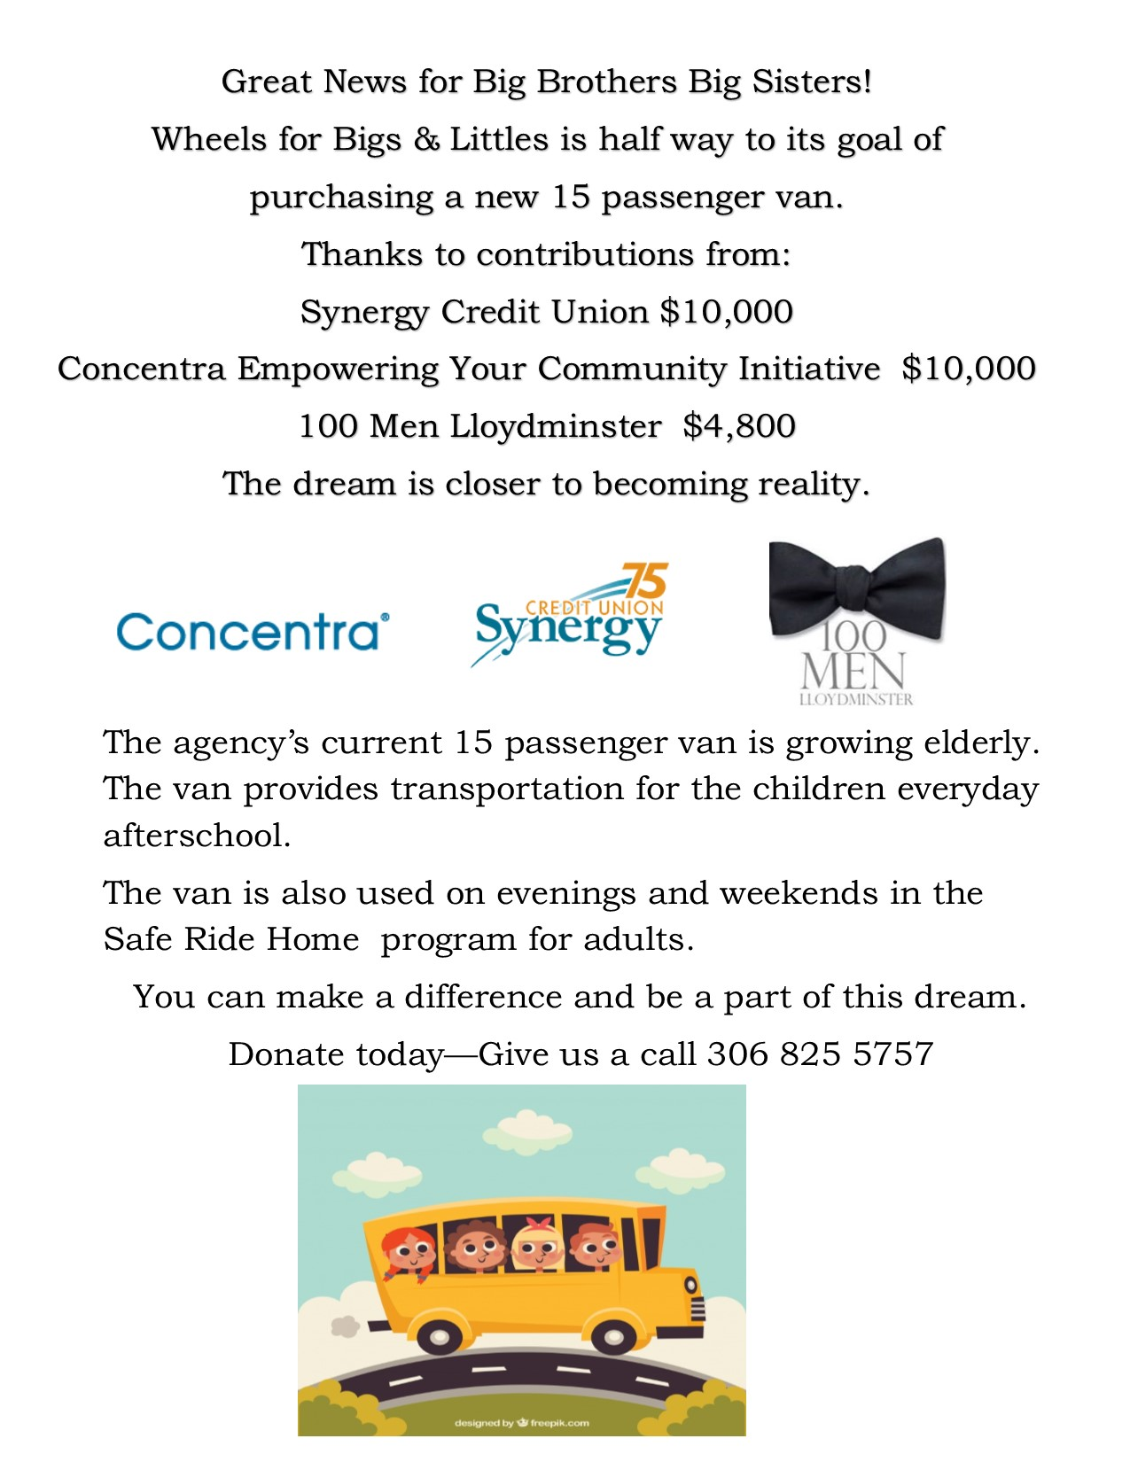
Legacy of Giving

We’re Big Brothers Big Sisters and we believe in the value and values of mentoring.

Big Brothers Big Sisters gives you the opportunity to help children in your community who are in need, during your lifetime and beyond.

Your gift will go to support the agency and its mentoring programs, allowing Big Brothers Big Sisters to continue meeting the needs of the community by offering local children and teens a brighter future.

Thoughtfully planning your charitable giving goes beyond commitment, it helps you find the best way to give while maximizing your tax benefits and making the most effective use of your resources.

Explore the possibilities and find the way of giving that is best for your needs.

Examples of Legacy Gifts: Outright Gifts, Charitable Bequests, Life Insurance, Charitable Remainder Trust

For more information about the agency and the mentoring programs we provide please contact the Executive Director at 306-825-5757.

Please consult a qualified taxation professional, tax implications vary based on your particular circumstances. The information is intended to provide an overview of giving options. After reviewing this material you are encouraged to consult with your professional advisors for advice on how you can use charitable giving to achieve your goals.
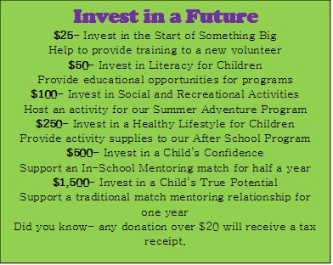

Our Wish List
- Digital camera
- New outdoor sign for building
- Well cared for, used, extended cab half ton truck
- Swivel wall mount for 52” TV
October Program Highlights:  - Meditation  - Yoga  - Servus Sports Centre  - Kids in the Kitchen (carrot pudding)  - SPCA  - Halloween Activities | 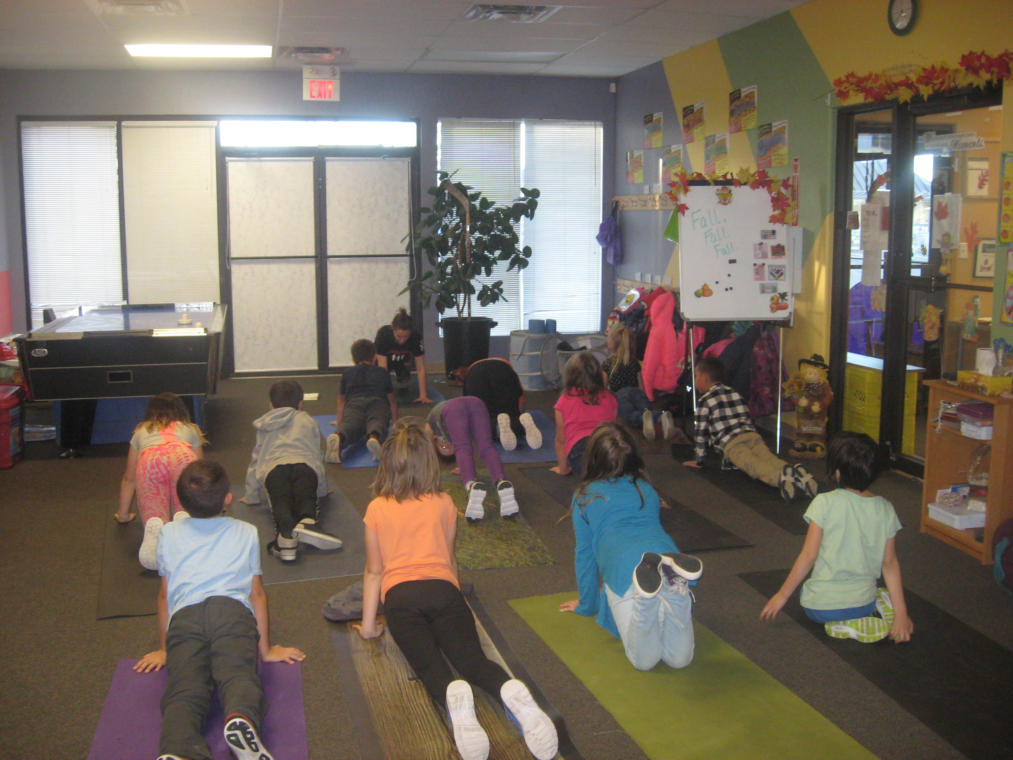
IN SCHOOL MENTORING
No school Nov 12 – 16

Please let Jacquie or Kayla know if there is something you would like put into the activity bin.

If you or anyone you know is interested in volunteering in any way please do not hesitate to contact the BBBS office at 306-825-5757.

We would love to have you as a mentor.

Afterschool program

- There will be NO PROGRAM for the week of November 12 – November 16.
- Program times are 3:15PM – 5:00PM.
- Pick up time is 5:00PM–5:20PM. Please let us know if you need to pick up your child early.
- Make sure you have talked with the school and let them know that your child is coming to program – either by bus or by van.
- Your child will need to have a pair of indoor running shoes here to wear during program. Slippers/flip flops will not work as we must have runners for Servus Sports Centre field trip.

Congratulations to:

Todd M & Austin Y 3 Year Anniversary
New Matches:
Blou & Ryder

Do not forget to send me pictures of your match – we love to hear how the match is going.

Start your Christmas shopping early
Check out our Christmas shopping table at our office from November 5 – December 7
Items will be $1.00 - $5.00

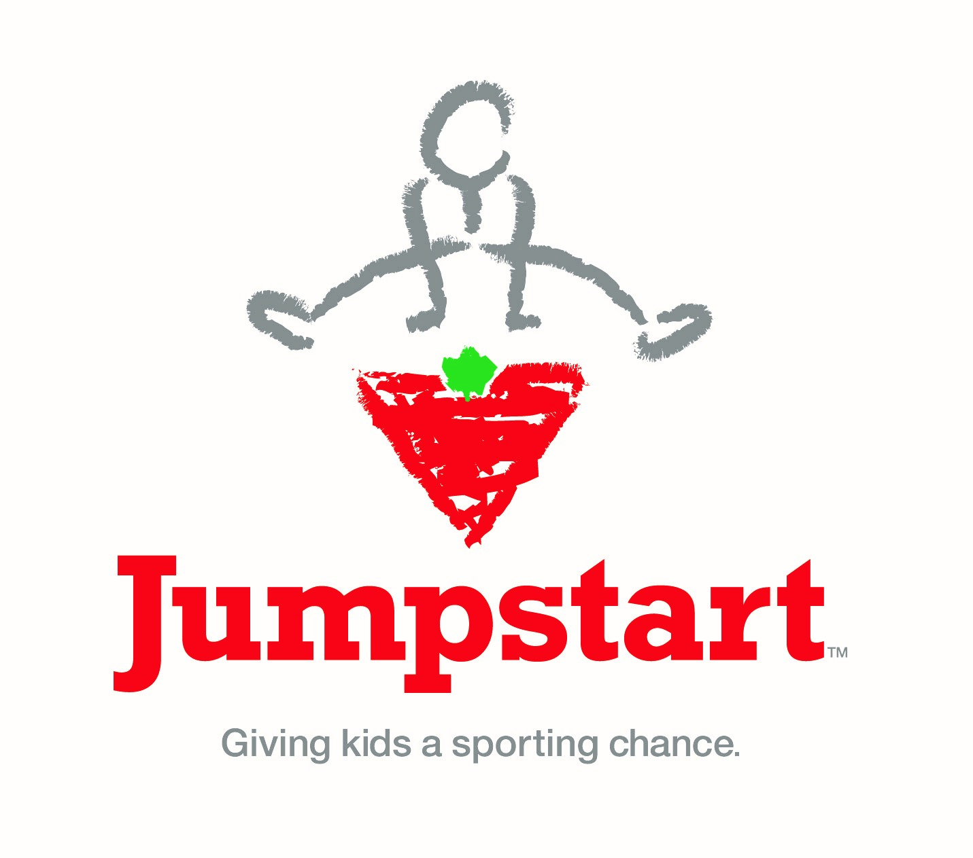
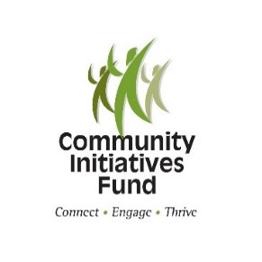
Donor Information
Thank you to our donors
October 2018 to September 2019

Lloydminster Columbus

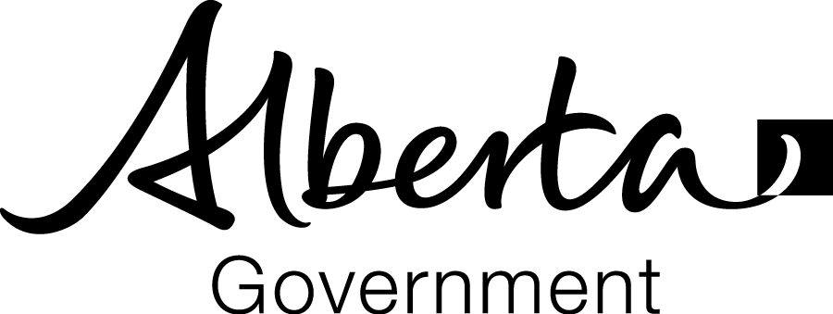
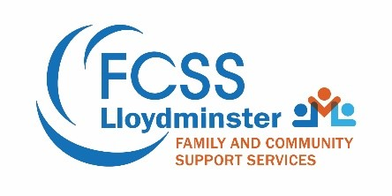
Club Charitable Foundation Inc.

My favorite food is chicken on the bone!
- Myah
[Grab your reader’s attention with a great quote from the document or use this space to emphasize a key point. To place this text box anywhere on the page, just drag it.]

Yes! I want to make a difference in the life of a child through Big Brothers Big Sisters of Lloydminster.
Did you know you can contribute to Big Brothers Big Sisters of Lloydminster online with CanadaHelps.org? Choose a donation that suits you: one time, monthly, charitable gift or in memory of someone. Makes a great Christmas gift. Follow CanadaHelps.org easy steps to find us and donate today!

Congrats to the following matches:

◄ October | November 2018 |  |  |  |  | December ►
Sun | Mon | Tue | Wed | Thu | Fri | Sat
 |  |  |  | 1 | 2 | 3
4  Daylight Savings Time Ends | 5 | 6 | 7  Recycling 9:00am | 8 | 9 | 10
11 Remembrance Day | 12  Office Closed  No Program | 13  No Program | 14  Recycling 9:00am  No Program | 15  No Program | 16  Controlling @ Christmas Craft Show  No Program | 17  Designated Driving @ Rolling Greens  Controlling @ Christmas Craft Show
18 | 19 | 20  National Child Day | 21  Recycling 9:00am  Early Dismissal | 22 | 23 | 24  Controlling: Christmas House Light Launch  Designated Driving @ Stockade
25 | 26  Board Meeting | 27  Giving Tuesday | 28  Recycling 9:00am | 29 | 30

