YOU ARE INVITED TO

Big Brothers Big Sisters of Lloydminster

Annual General Meeting

& Community Recognition
To be held virtually

Wednesday January 20, 2021
12:00 to 1:00PM
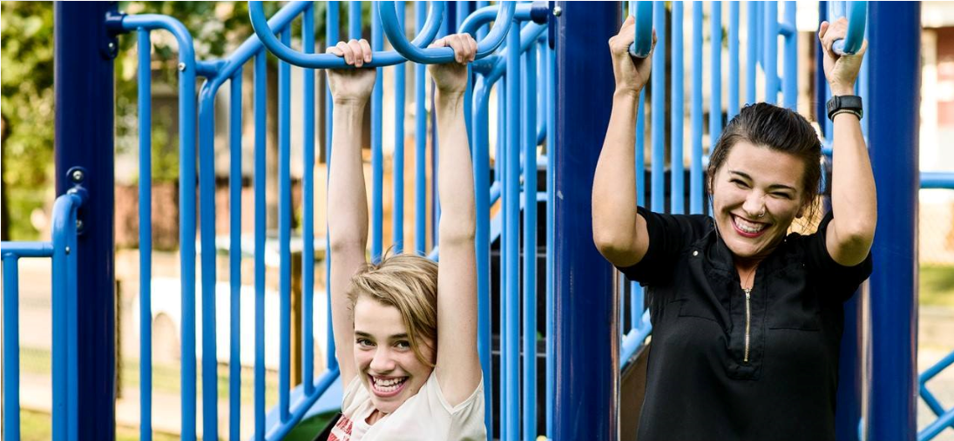
This is what mentoring looks like!
Please RSVP to brobinson@bbbslloydminster .ca
by January 15, 2021
Details to join the meeting will be emailed to those that have register on January 18, 2021
BIGGER TOGETHER - IGNITING POTENTIAL

